FOR IMMEDIATE RELEASE

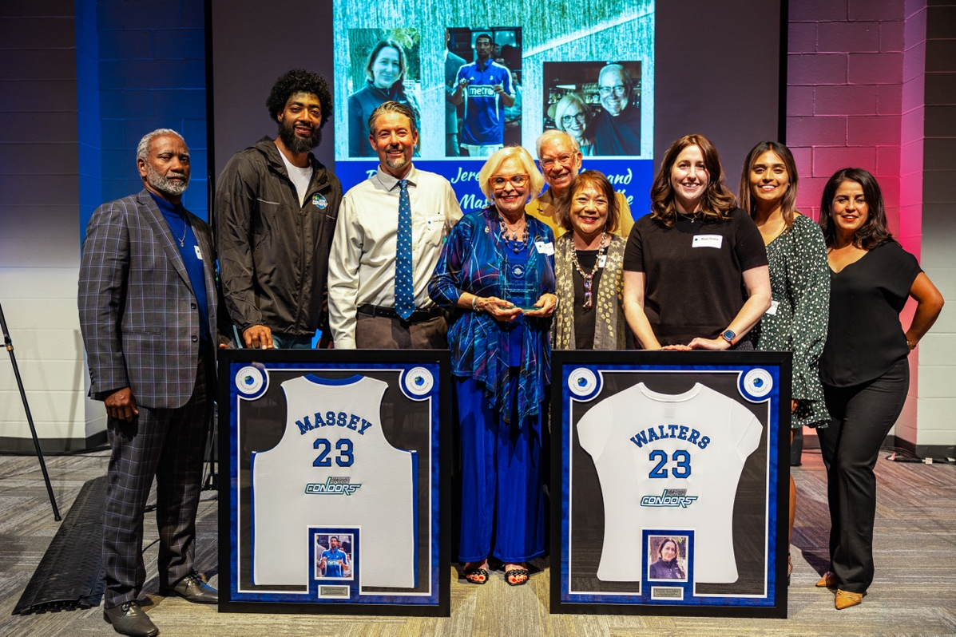

The Oxnard College Athletic Alumni Association’s 2023 Hall of Fame recipients

**Oxnard College’s Athletic Department Hosts Third Annual Hall of Fame Banquet***College to honor homegrown talents, Tenley Garcia, Jon Larson, and Marti Dibble*

**Oxnard, Calif.** (April 30, 2024) — The Oxnard College Athletic Alumni Association is hosting its third annual Hall of Fame event on Saturday, May 11, at the Oxnard College Performing Arts Center. Former athletes, alumni, and the general community are invited to attend the reception and luncheon to honor three exceptional former Condors: Tenley Garcia (1999-2001), Jon Larson (1979-1980), and Marti Dibble (1985-2013).

Honoree Tenley Garcia participated in the Oxnard College Women’s Soccer team from 1999 to 2001 and was voted the Western State Conference (WSC) Player of the Year. Garcia received a scholarship and was recruited to play at Holy Names University, in Oakland, California, where she received her bachelor’s degree in business. In Oakland, Garcia joined the San Francisco Nighthawks where she continued her remarkable soccer career. She then moved back home and took on an assistant coaching position at Oxnard College while playing for the newly established Ventura County Fusion (VCF) team. During her time with VCF, Garcia led her team in goals and was quickly recruited to play for the Santa Clarita Blue Heat. Garcia now owns a landscaping business and resides in Oxnard with her husband and her three-year-old son.

Honoree Jon Larson participated on the Oxnard College Baseball team from 1979 to 1980. In his first year, Larson was part of the historic team that clinched the WSC Championship under the guidance of Jerry White, a 2022 Oxnard College Athletic Alumni Association Hall of Fame inductee. In his second year, Larson led the state in batting, with an impressive .489 average. Larson was named First-Team Junior College All-American and Oxnard College Athlete of the Year. His exceptional skills earned him a scholarship to Fresno State University. After his athletic career, Larson returned to Oxnard College where he served as head coach for the baseball team from 1999 to 2018. Under his leadership, the Condors claimed multiple WSC Championships and consistently qualified for playoffs. Additionally, Larson holds a record-breaking 423 wins for Oxnard College. Impressively, Larson was also inducted into the California Community College Baseball Hall of Fame in 2019.

Honoree Marti Dibble is set to receive the Lifetime Condor Award. Dibble was employed at Oxnard College in 1985, when she began operating the athletics program out of a modest space with minimal amenities. Dibble’s commitment helped support students and grow the program over time. Additionally, during the 1994 World Cup, Dibble had the privilege to work with the Cameroon National Team. After retiring in 2005, Dibble became an adjunct instructor, working with future generations of aspiring athletic trainers. She departed OC in 2013, leaving a proud legacy of excellence.

Tickets for the third annual Hall of Fame Gala are available for $50 per person and may be purchased through the Oxnard College Athletic Alumni Association’s website at [www.OCAthleticAlumni.com](https://www.ocathleticalumni.com/).

|  |
| --- |
|  |

**About Oxnard College**

*Oxnard College is one of three colleges in the Ventura County Community College District and annually serves more than 7,000 students. Founded in 1975, Oxnard College is fully accredited. It is also a designated Hispanic-Serving Institution. Oxnard College’s signature programs include marine biology; culinary arts, restaurant management and hospitality management; auto technology, dental hygiene, and fire technology, among many other undergraduate study and career technical education programs. The Dream Resource Center is a valuable student and community resource. To learn more, visit*[*oxnardcollege.edu*](http://oxnardcollege.edu/)*and*[*Facebook*](https://www.facebook.com/oxnardcollege/)*,*[*Instagram*](https://www.instagram.com/oxnardcollege_official/)*,*[*LinkedIn*](https://www.linkedin.com/school/oxnard-college/)*and*[*Twitter*](https://twitter.com/OxnardCollege)*.*

Media Contact:

James Schuelke

Director of Outreach and Marketing

Oxnard College

805-678-5275

[jschuelke@vcccd.edu](mailto:jschuelke@vcccd.edu)