

FOR IMMEDIATE RELEASE

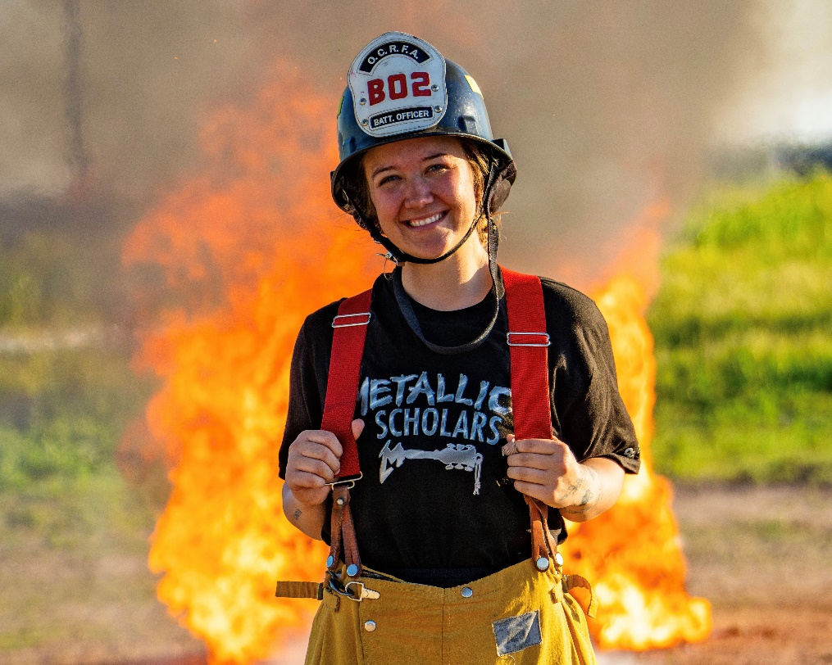

Oxnard College Receives $50,000 Grant Renewal from Metallica’s All Within My Hands’ Scholars Initiative
Oxnard College has received a $50,000 grant renewal from the Grammy Award-winning band Metallica’s foundation, All Within My Hands (AWMH). The award follows an initial grant of $100,000 issued last year and will continue supporting students in the college’s Culinary Arts, Dental Hygiene and Fire Academy programs as the band continues its multimillion-dollar investment in critical workforce programs at community colleges nationwide.
The Metallica Scholars Initiative (MSI) was launched in 2019 by AWMH in partnership with the American Association of Community Colleges (AACC). MSI offers diverse workforce opportunities for students interested in gaining the skills and training necessary to find meaningful and well-paying careers. Additional curricula is set to include construction, healthcare, and engineering, contributing to more than 25 fields of study offered within the Initiative. To date, AWMH has invested over $10.5 million in the American workforce, reaffirming a commitment to career and technical education at the local level including at Oxnard College over the past two years.
“We are honored to continue our partnership with Metallica to support career education and the trades here at Oxnard College,” shared Dr. Roberto Gonzalez, president of Oxnard College. “This funding will provide much-needed scholarships and technical instruments to our students, helping to train and equip Ventura County’s workforce. We are grateful to Metallica and its foundation, All Within My Hands, for renewing their support of our students and community.”
This year’s newest cohort of grant recipients represents the greatest expansion of MSI and its largest grant to date. With the launch of year six, 18 new colleges join the roster of existing MSI community colleges, with each new college receiving $75,000 to enhance the student experience within career and technical education programs. The Metallica Scholars Initiative now has a presence in 60 colleges across all 50 United States and the territory of Guam.
“When we launched the Metallica Scholars Initiative, it really spoke to me,” said James ‘Papa Het’ Hetfield, lead vocalist, guitarist, and co-founder of Metallica. “A collective goal of breaking the stigma of trade skills. Trade skills are vital to society, and what’s even more important is to support the many folks who are trying to create a career by learning and using these skills. I am so proud — we all are — to see how this program is changing lives by providing much-needed resources to empower students, and it’s great that we’re able to make our biggest grant yet to support these students and the future workforce. We are reaching even further for year six of the Metallica Scholars Initiative. This year, our program will be in 60 schools in all 50 states! All thanks to your support.”

The grant will fund equipment for Oxnard College students such as fire safety boots for Fire Academy cadets, professional knife kits for Oxnard College’s Culinary Arts students and dental instrument kits for Dental Hygiene students. Oxnard College’s services for career education students will also extend counseling and subsidized services such as childcare, SNAP benefits and other support to Metallica Scholars and their families.

“I am happy to congratulate the newest Metallica Scholarship Initiative colleges. The sustained investment in workforce education by the All Within My Hands Foundation has benefitted thousands of community college students,” said Walter G. Bumphus, president and CEO of AACC. “This work helps to advance skills education and the nation’s workforce pipeline. We are honored to continue this partnership to provide critical resources that eliminate barriers for students to participate in skills education programs that lead to family-sustaining wage careers.”

By the end of year six, AWMH estimates the organization will have helped more than 8,000 students with a wide range of backgrounds and ages gain skills to assist in finding meaningful jobs and careers. Metallica Scholars are often considered non-traditional students, as many have families they support or are the first in their families to pursue a college education. AWMH and AACC aim to connect students to skill-building opportunities and bridge the talent needs of the American workforce, all while utilizing the community college system, which is the most affordable, flexible and industry-relevant applied-learning training provider in the country.

“Metallica, through their foundation, is changing how people view and engage with the trades in this country, and it is working,” stated Peter Delgrosso, Executive Director of All Within My Hands. “Metallica Scholars are diverse, motivated, and ambitious, and we are here to help them reach their goals. I am so proud and honored to be able to announce entrance into all 50 states as this is a significant milestone for not only our foundation but the incredible community we have helped foster and connect.”

The Oxnard College Foundation will relaunch its community fundraising campaign to support the college’s career and technical education programs. Help match Metallica’s grant through the Foundation’s campaign at oxnardcollegefoundation.org/metallica-scholars. For a complete list of all 60 colleges currently supported by AWMH, visit allwithinmyhands.org/metallica-scholars.

About Oxnard College
Oxnard College is one of three colleges in the Ventura County Community College District and annually serves more than 7,000 students. Founded in 1975, Oxnard College is fully accredited. It is also a designated Hispanic-Serving Institution. Oxnard College’s signature programs include marine biology; culinary arts, restaurant management and hospitality management; auto technology and fire technology, among many other undergraduate study and career technical education programs. The Dream Resource Center is a valuable student and community resource. To learn more, visit oxnardcollege.edu and Facebook, Instagram, LinkedIn and Twitter.
About All Within My Hands
All Within My Hands (AWMH) is a non-profit, philanthropic organization conceived by the members and management of Metallica and dedicated to creating sustainable communities by supporting workforce education, the fight against hunger, and other critical local services. 100% of donations go directly to local organizations that the Foundation supports. To date, All Within My Hands’ collective efforts have raised over $15M— providing $8.2M in grants to career and technical education programs, over $3.6M to combat food insecurity, and more than $3.5M to disaster relief efforts. To learn more about All Within My Hands, Visit AllWithinMyHands.org and follow us on Instagram, X, Facebook, and LinkedIn.
About AACC
As the voice of the nation’s community colleges, the American Association of Community Colleges (AACC), delivers educational and economic opportunity for more than 10 million diverse students in search of the American Dream. Uniquely dedicated to access and success for all students, AACC’s member colleges provide an on-ramp to degree attainment, skilled careers, and family-supporting wages. Located in Washington, D.C., AACC advocates for these not-for-profit, public-serving institutions to ensure they have the resources and support they need to deliver on the mission of increasing economic mobility for all. For more information, visit https://www.aacc.nche.edu/.
Media Contact:
Lisa Putnam
Outreach and Marketing
Ventura County Community College District
lputnam@vcccd.edu

